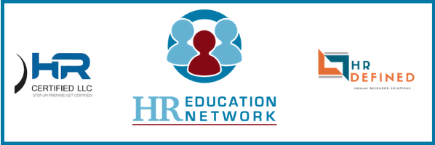

HR Education Network – Instructor-led HR Certification Test Preparation
“You Pass or Your Money Back” for PHR/SPHR
We are so certain that using our instructor-led online HR certification test preparation program will prepare you to pass the HR certification exam, we'll give you your money back if you don't pass.
Why we offer a money back guarantee
We have confidence in our program. If you learn the material and take the practice tests, you will be prepared to pass the PHR or SPHR exam. We’re willing to bet on it.
What do I need to do to qualify for the money-back offer?
- Purchase the complete 2019 HREN Instructor-led HR Certification Test Preparation course.
- Attend a minimum of 90% of the online video sessions (10 out of the 11 regular sessions, in addition to the on-demand introduction)
- Read and study all five units and the online Guide for Successful Exam Preparation.
- Complete all 18 practice tests at hrcp.com, scoring 80% or better on each test, prior to your PHR/SPHR exam date. (You can retake the practice tests as needed.) Keep in mind that each test can be taken only once every 24 hours.
- Take the PHR/SPHR certification exam within 90 days of the completion of your HREN course.
- If you don’t pass, you can either:
- Opt to enroll you in the next instructor-led course at no additional charge. Retake the course meeting all of the above criteria.

- OR

- If you have met all of the criteria, will refund the price of your certification test preparation program in full.

How do I go about requesting a refund? To request a refund, submit the following information via email or fax:
  - A completed Refund Request Form (next page of this document)
  - A copy of your official Examination Results from the HR Certification Institute (first test and retake)
  - A copy of your receipt showing your purchase from HR Education Network.
  - A copy of a minimum of 10 out of 11 of your HR Education Network completion certificates.
Upon receipt and approval of your refund request, a Refund Authorization form will be sent to you via email. Please note that this offer is available only to residents of the United States. This offer can only be redeemed by one individual per purchased test preparation program. Additionally, the PHR/SPHR exam fees are not covered by this offer.

HR Education Network “You Pass or Your Money Back” - PHR/SPHR Refund Request Form

Name ___________________________________
Street address ____________________________
Phone number ____________________________
I am a resident of the United States.
Company ________________________________
City, State, ZIP ___________________________
Email address ____________________________
I purchased the 2019 HR Education Network Program directly from HR Education Network.
I have read and studied all five units of the 2019 HRCP Program in their entirety, as well at the online Guide for Successful Exam Preparation.
I completed the 18 practice tests on the hrcp.com website prior to my SPHR exam, and I scored 80% or better on each test. Scores and dates completed are recorded below.
Unit 1 Practice Tests |  |  | Unit 4 Practice Tests
Form | Score | Date | Form | Score | Date
A |  |  | A
B |  |  | B
PHR/SPHR |  |  | PHR/SPHR
Unit 2 Practice Tests |  |  | Unit 5 Practice Tests
Form | Score | Date | Form | Score | Date
A |  |  | A
B |  |  | B
PHR/SPHR |  |  | PHR/SPHR
Unit 3 Practice Tests |  |  | Comprehensive Practice Tests
A |  |  | A
B |  |  | B
PHR/SPHR |  |  | PHR/SPHR

I am including with this form:
A copy of my official Examination Results from the HR Certification Institute showing the date of my PHR/SPHR exam and my failing score for both the original exam and the retake
and
A copy of my receipt showing my purchase from HR Education Network.
I attest that the above information is true, and I acknowledge that inaccurate information may invalidate my request for a refund.

Signature_____________________________Date:_____________

Please email Refund Request Form and PHR/SPHR Examination Results to Jessica.vieira@hreducationnetwork with the subject line: HR Certification Test Preparation Refund Request

